|  |  |  |  |
| --- | --- | --- | --- |
| **Lyng Primary School Knowledge Organiser** | | | |
| **Geography** | **Women who changed the World and Chocolate**  **What is the rainforest?**  **What environmental features are there in a seaside town?** | Year 1 | Summer |

|  |  |
| --- | --- |
| **What Step On and Goldilocks words will I use?** | |
| **Spelling** | **Definition** |
| geography | The study of land, sea and the people who live there. |
| land | The solid surface of the Earth which is not covered by water. |
| rainforest | A rainforest is a special kind of forest where it's very hot and rainy. It's like a big, green jungle with lots of tall trees, colourful plants, and all kinds of animals. |
| landscape | The [**landscape**](https://www.collinsdictionary.com/dictionary/english/landscape) is everything you can [see](https://www.collinsdictionary.com/dictionary/english/see) when you [look](https://www.collinsdictionary.com/dictionary/english/look) across an area of land, including [hills](https://www.collinsdictionary.com/dictionary/english/hill), [rivers](https://www.collinsdictionary.com/dictionary/english/rivers), buildings, trees, and plants. |
| environment | The natural world of land, sea, air, plants, and animals. |
| location | A location is the place where something happens or is situated. |
| river | A river is like a long, winding pathway made of water that flows through the land. |
| humid | Humid means the air around us feels wet and sticky. |
| Harbour | A harbour is a special place near the ocean where boats and ships can stay safe. It's like a big parking lot for boats! |
| coast | An area where land meets ocean. |
| forest | A lot of trees growing over a large area. |
| hills | A hill is like a big bump or a small mountain on the land. |



**Seaside town – Mary Anning**

Mary Anning was a famous fossil hunter who lived a long time ago in a town called Lyme Regis. She was born there on May 21, 1799. Lyme Regis is a beautiful seaside town in England, where Mary spent lots of time exploring the beaches and cliffs.

Mary loved searching for hidden treasures in the rocks along the shore. She found amazing fossils of creatures that lived a very long time ago, like huge sea monsters! Her discoveries helped scientists learn more about ancient animals.

**Rainforest – Chocolate**

In the rainforest, there's a special tree called the cacao tree that grows delicious chocolate! The cacao tree is found in places like the Amazon rainforest in South America. The cacao pods grow right on the trunk of the tree.

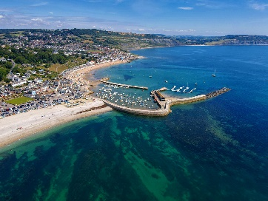

|  |
| --- |
| **Geographical study** |
| Features of Lyme Regis, seaside town:   * Shops * Sea * Sand * Harbour * Houses * Hills   Lyme Regis is in Dorset. Children will locate on a map.  Children will be studying the **Amazon Rainforests**, where there are many cocoa trees. The Amazon Rainforest is a huge, amazing place in **South America**, filled with trees, plants, and animals. It's so big that it spreads across many countries like **Brazil, Peru, and Colombia**. The Amazon Rainforest has a giant **river called the Amazon River**. The rainforest is full of tall trees with big leaves that make a roof over the whole forest. This roof is so thick that it keeps the forest floor dark and cool. The weather in the Amazon Rainforest is **hot and humid.** It rains a lot, which helps all the plants and animals grow big and strong. The Amazon Rainforest is like the Earth's lungs because it breathes in carbon dioxide and breathes out oxygen, which helps keep our planet healthy. |

**Fieldwork Opportunities**

Walk around West Bromwich. What similarities and differences do we have with the Amazon Rainforest?

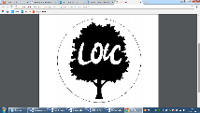

**Significant places**

* Lyme Regis
* Amazon Rainforests
* South America

**Our Storytelling Approach to enhance engagement**

|  |  |  |
| --- | --- | --- |
| **People:**  Mary Anning | **Place:**  Lyme Regis | **Problem:**  Mary Anning needs to find more ‘curiosities’. Where should she look? |

**Key facts and locations**

**Map to be studied**

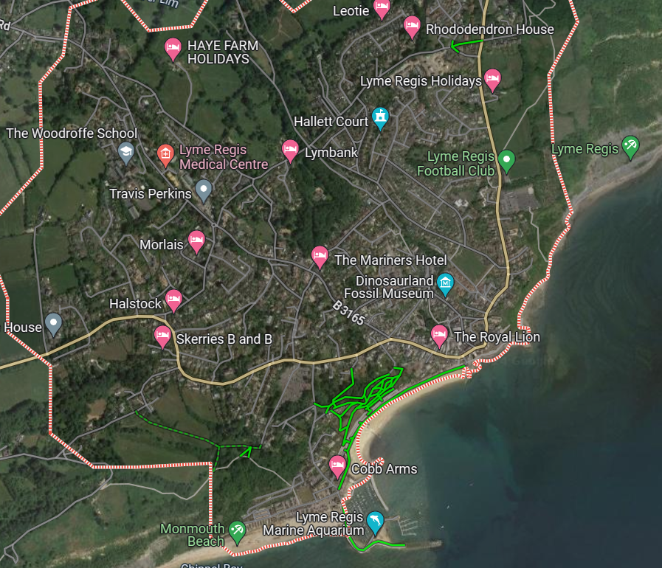

Lyme Regis:

1. **Beach**: Lyme Regis has a beautiful beach where you can build sandcastles, play in the waves, and look for seashells.
2. **Jurassic Coast**: It's a special place because it's part of the Jurassic Coast, where you can find fossils of dinosaurs and ancient sea creatures.
3. **Harbor**: There's a small harbour where colourful boats come and go, bringing in fresh fish and taking people on boat rides.
4. **Cobb**: One of the town's most famous features is the Cobb, a big wall made of stones that stretches out into the sea. You can walk along it and enjoy the view of the ocean.
5. **Shops and Cafes**: Lyme Regis has cute shops and cafes where you can buy souvenirs, ice cream, and yummy snacks.
6. **Festivals**: Throughout the year, Lyme Regis hosts fun festivals and events, like the Lyme Regis Fossil Festival, where you can learn all about fossils and dinosaurs.
7. **Surrounding Nature**: Around Lyme Regis, there are cliffs and green hills where you can go for walks and see beautiful views of the town and the sea.
8. **Friendly Atmosphere**: People in Lyme Regis are friendly, and the town has a relaxed vibe, making it a great place for families to visit and have fun by the sea.

**Key questions**

**Agreed Outcome**

Make a travel guide for Lyme Regis.

* What are the key features of the costal town Lyme Regis?
* What is a rainforest?
* Where is the Amazon Rainforest?
* What is the weather like in the Amazon Rainforest?

|  |  |  |  |
| --- | --- | --- | --- |
| **Lyng Primary School Knowledge Organiser** | | | |
| **Topic: Geography** | **What is the rainforest?**  **What are the environmental features of Lyme Regis?** | Year 1 | Summer |

|  |  |  |
| --- | --- | --- |
| 1. Where is chocolate grown? | **S** | **E** |
| Tesco |  |  |
| A tropical rainforest |  |  |
| West Bromwich |  |  |

|  |  |  |
| --- | --- | --- |
| 1. Where is Lyme Regis? Find it on a map. |  |  |
| **S** | | |
| **E** | | |

**Rainforest and seaside**

**Quick Quiz**

|  |  |  |
| --- | --- | --- |
| 1. Which country does not have a **tropical** rainforest? | **S** | **E** |
| England |  |  |
| Brazil |  |  |
| Peru |  |  |

|  |  |  |
| --- | --- | --- |
| 1. What is the weather like in a **tropical** rainforest? | **S** | **E** |
| cold |  |  |
| snowy |  |  |
| hot and humid |  |  |

|  |  |  |
| --- | --- | --- |
| 1. Which is not a feature of Lyme Regis? | **S** | **E** |
| London Eye |  |  |
| Beach |  |  |
| Harbour |  |  |

|  |  |  |
| --- | --- | --- |
| 1. Under the trees it is…. | **S** | **E** |
| Light and breezy |  |  |
| Dark and hot |  |  |
| Rainbow |  |  |